Student Name：**Jiachen Luo (001061582)**

**INFO 6205**

**Program Structure & Algorithms**

**Spring 2021**

**Assignment3**

**Task:** Implement height-weighted Quick Union with Path Compression.

UF_HWQUPC classs:

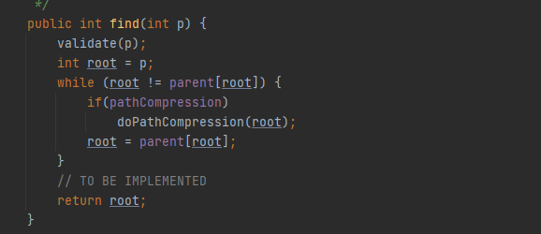

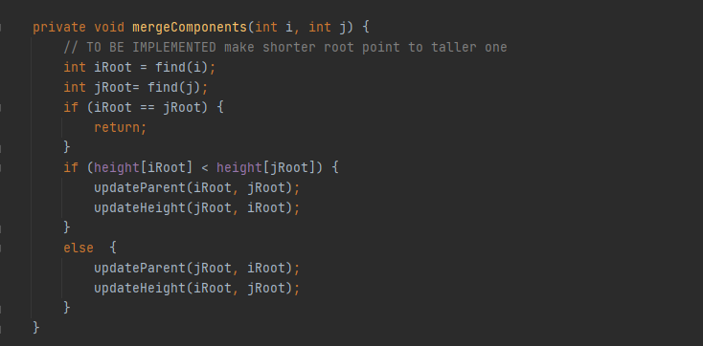

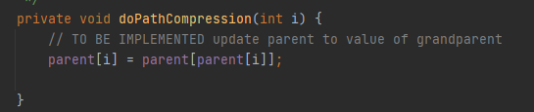

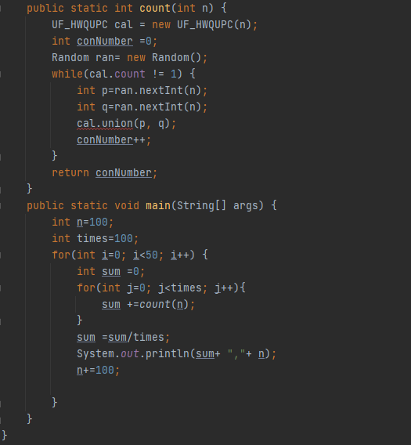

**Output:**

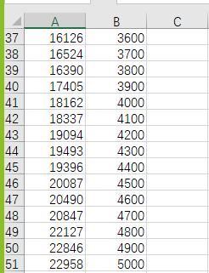

**Relationship Conclusion:**

pairs=4.5*objects

**Graphical representation:**

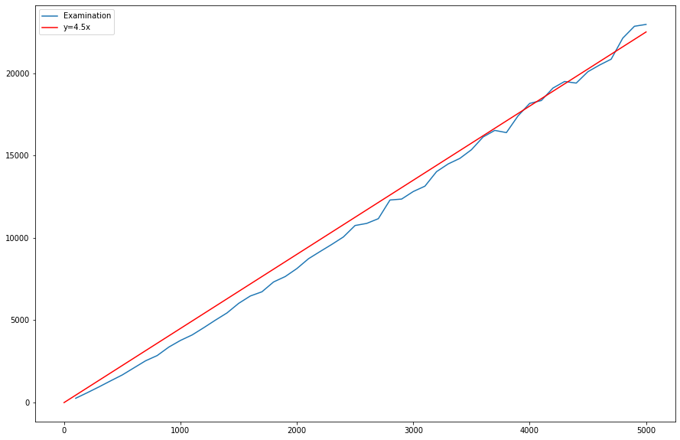

**Unit tests result:**

UF_HWQUPC_test

